Name__________________________________________________ Block_________ Date__________________________

Blood Spatter & Angle of Impact Analysis

Safety Precautions: Wear goggles and gloves at all times. Use caution when working with sterile bovine blood samples. Clean lab surfaces and wash hands at the conclusion of lab.

Materials: Goggles, gloves, board, ruler, protractor, string, masking tape, white paper, sterile bovine blood, synthetic blood, disposable dropper, butcher paper

Part One: Angle of Impact
- Obtain a board, ruler, protractor, masking tape, white paper, sterile bovine blood, and disposable dropper.
- Tape the white paper to the board, and drop one drop of blood (from a height of about a half foot above the paper) at each of the following angles: 20°, 45°, 70°, and 90° (board flat on the table).
- Measure the WIDTH and LENGTH (not including tails) of the drop on the paper.
- Calculate the angle of impact: Angle of Impact = sin⁻¹(width/length)
Set Angle | Length (mm) | Width (mm) | Calculated Angle
20°
45°
70°
90°

Part Two: Area of Origin
- Obtain a large piece of butcher paper, ring stand, string, protractor, ruler, masking tape, and synthetic blood.
- Place the butcher paper flat on the center of your table.
- Pool a small amount of synthetic blood in the palm of one hand, hold it above the paper (record the height: _____________________cm), and strike the blood with the other hand, spattering it onto the paper.
- Inspect the blood drops on the paper, and choose 5 drops (in various locations) to measure and calculate angle of impact.
Blood Drop | Length (mm) | Width (mm) | Calculated Angle
#1
#2
#3
#4
#5
- Use the protractor, tape, and ring stand to set up string at the correct angles, connecting each blood drop back to the ring stand. By using the protractor to make sure that your strings are all at the correct angles, you can set the height of your ring stand to mark the area of origin.
- Record the triangulated height of your area of origin: ______________________cm
Part Three: Pattern Analysis
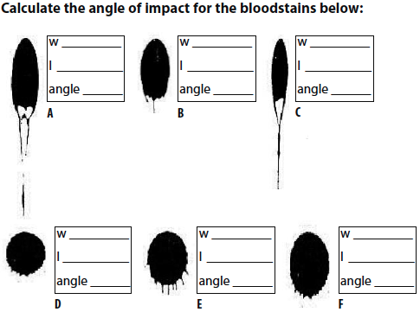
For each image of blood spatter below, describe what may have cause the observed pattern
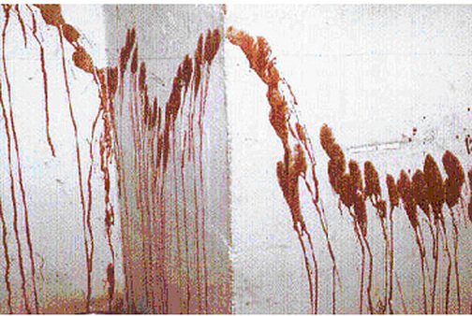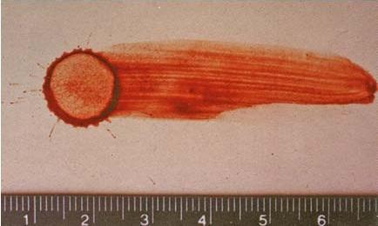

Analysis & Conclusion Questions
- How accurately were you able to calculate the angle of impact in Part One?

- How might this type of calculation be useful in forensic analysis?

- How accurately were you able to triangulate the area of origin for the point of impact in Part Two?

- How might this type of calculation and triangulation be useful in forensic analysis?

- How does blood pattern analysis help forensic scientists recreate crime scenarios?

